Observing climate change with a

3D-printed Moon Rabbit

Over the past few decades, the concentration of CO2 in Earth's atmosphere has increased significantly. In the late 1950’s, atmospheric CO2 concentration was around 320 parts per million (ppm); today, it stands at over 420 ppm. The Figure below shows data from researchers at the Mauna Loa Observatory in Hawaii. The growth has been almost linear despite international agreements, such as the Kyoto Protocol, the Paris Accord and 28 annual United Nations Climate Change Conferences. Even the organiser of the most recent conference at the time of writing, COP28, had to deny claims of climate scepticism.

Figure 1. The scientific community has been aware of the effect of CO2 on the climate since 1896, when the Swedish Professor Svante Arrhenius published his epoch-defining paper *“On the influence of Carbonic Acid in the Air upon the Temperature of the Ground”*. And as you can see on the right, no limitation on the growth of CO2 rates has been forthcoming. 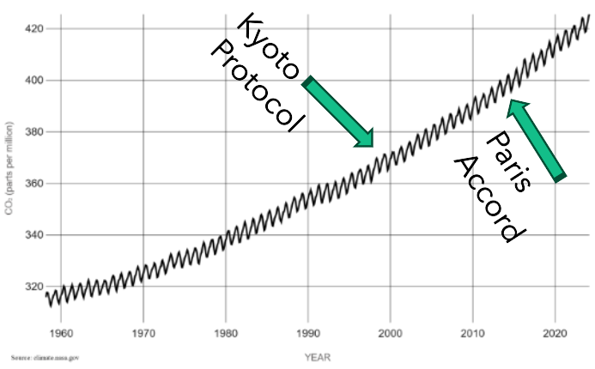

The mechanism is as follows: the Sun heats the Earth’s surface. The Earth emits infrared radiation in accordance with Planck’s law. Greenhouse gases, including CO2, absorb the IR radiation and warms the atmosphere. The lowest layer of the Earth’s atmosphere is called the Troposphere and is about ten kilometres thick, so that even a small change to CO2 levels, magnified by the thickness of the lower atmosphere, will have material consequences.

Figure 2. Going back a bit further, research in Polar Ice Cores (see left) shows CO2 concentrations going back 2000 years.  
  
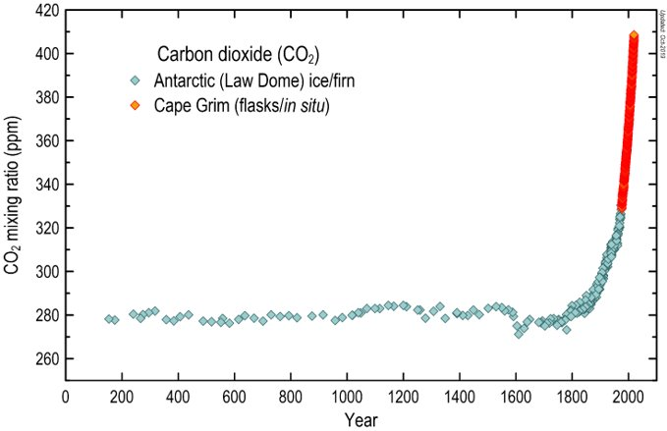

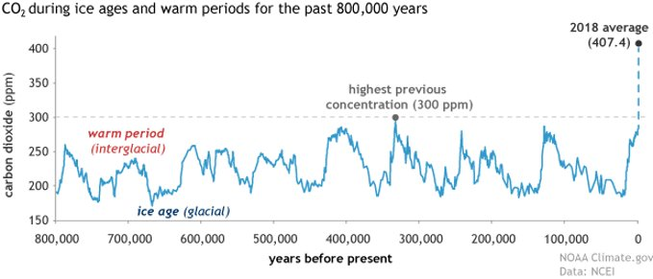Figure 3. To some extent, CO2 concentrations are cyclical, but at 420 ppm, we are already 40 % above the previous maximum for the last 800,000 years. In fact, the last time CO2 was at current levels was 20 million years ago, during the Cenozoic Era, a period characterised by the evolution of first giraffes, hyenas, giant anteaters and a large increase in bird diversity.

Figure 4. The Paris Accord's goals to limit warming and reduce emissions are beginning to take effect, as we are now beginning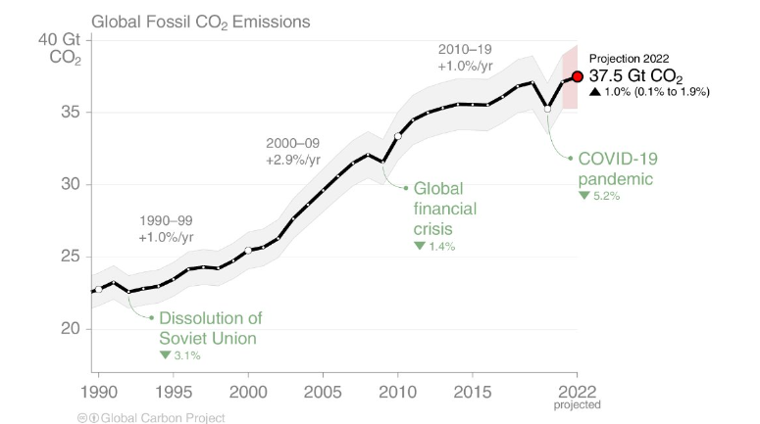 to level off at about 35 gigatonnes per year. This is still an enormous volume of CO2 annually, continuing to build up a carbon debt that future generations will have to pay back. A rough calculation of the CO2 emitted over the course of the time period in figure 1 gives us nearly 1,000 gigatonnes of accumulated carbon debt. Carbon dioxide has a half-life of about 120 years in the atmosphere before being absorbed, meaning that carbon emissions are not absorbed quickly by the planet. Trees and plants absorb about 35 % with oceans dissolving the remaining 65 % (and warming oceans will dissolve less). If we stopped all CO2 output today, half of our current CO2 debt would still be there in 2144.

Figure 5. As you can see, last year in 2023, we crossed the 1.5-degree level for a single year, but not yet the rolling average.   
  
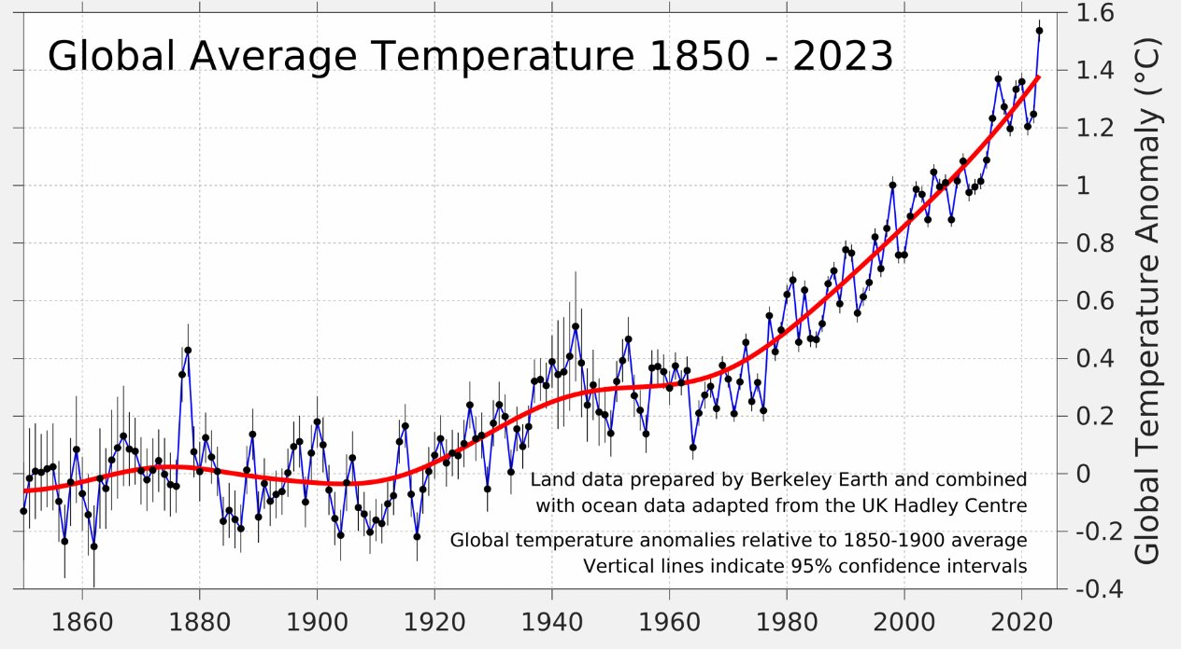

The Mauna Loa Observatory in Hawaii is recognised as the global standard for CO2 readings. Data has been collected by researchers there since 1958. NASA too funds considerable satellite-based CO2 measurement. How can we contribute to respond to this growing systemic instability in our environment?

The prototype described here is an attempt to democratise this data and educate and empower us all to help save our planet.

Moon Rabbit is a CO2 monitoring prototype, using similar, but consumer grade, NDIR (Nondispersive infrared) technology, to that used at Mauna Loa, based on the Senserion SCD30 sensor and a Raspberry Pi Zero 2 W. I call it the Moon Rabbit. In case you don’t know Moon Rabbit, or Jade Rabbit, is the Asian equivalent of the Man in the Moon. In the same way that a similar Pi-based earthquake detector is called “The Raspberry Shake”. I wanted a meme-based, astronomical brand name that would appeal across cultures. That's 4 billion potential astronomers and climate researchers.

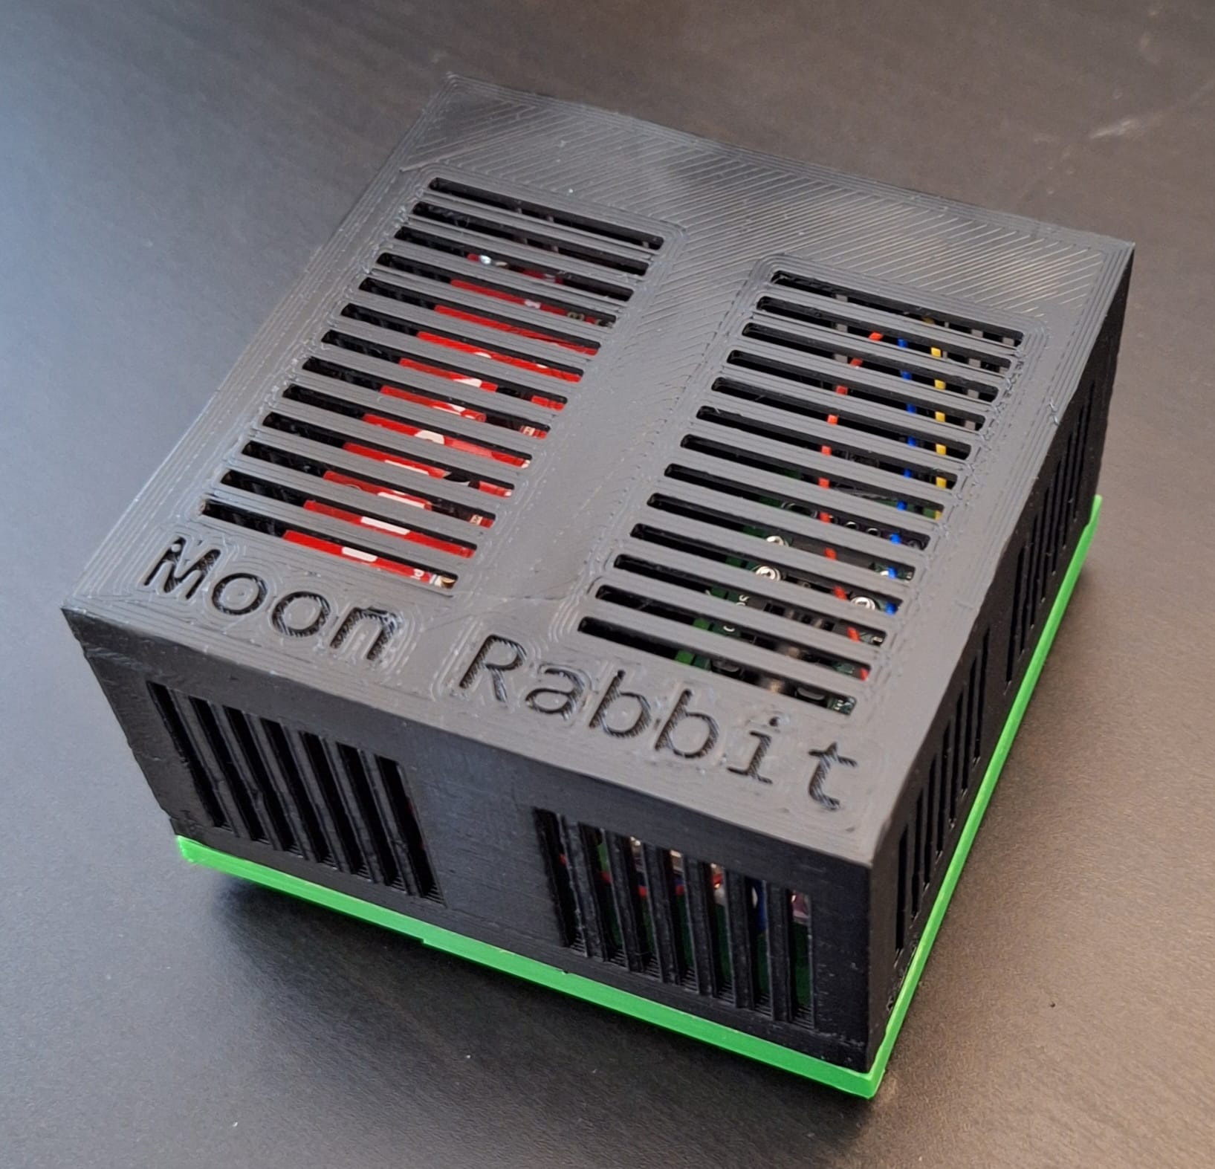Figure 6. The 3D printed Moon Rabbit runs Python and INDI and can connect to other astronomical devices, such as the Lunatica Cloudwatcher or the Davis Vantage Pro, to collect and share other weather-related data across the local community. We can imagine a site based on mapping technology showing dynamic weather crossing our locality. When it starts to rain in Haywards Heath, and the weather is moving North, we can see it will only be 15 or 20 minutes before it’s raining in Crawley. A friend of mine in the US is already running sessions of joint observing, where he takes spectra of a selected Be star, such as Omicron Andromedae, and tracks these over 12 hours using amateur astronomers in each time-zone from Europe to the West coast of the US. Such a project could facilitate such data exchanges. The project would also capture and publish real-time data on CO2 levels and weather conditions.

A significant material expense is calibration, and I need ideas about how to do this better. I currently buy calibration gas for calibration. A calibration for one to four instruments currently costs around £50.

Figure 7. This plot shows a Moon Rabbit being moved from my back garden, near a heath, to the front of my house with a road. The greater mean value and volatility is presumably down to road traffic. It needs research to find out.

Potential use cases requiring further research and development include:

1) Living near a road (CO2)

2) Urban versus rural living (CO2)

3) Gas central heating (CO2)

4) Living near an industrial area (CO2)

5) Year-on-year change (CO2)

6) Tracking a storm or clouds (Astronomy/Weather)

7) Analysing weather effects on seeing (Astronomy/Weather)

8) Collaboratively imaging the same object – comets, variable stars etc (Astronomy)

We need to start to collect and analyse our own data, especially on topics like climate change, rather than relying solely on scientists and governments. We can start to develop tools for community-based data collection on CO2 levels to better understand and address climate change.

But this is just the first step: getting people involved and informing them. Next, armed with data, we communicate, we can reach out and spread the word through websites, influencers and social media. We can democratise local data, providing the data to support our families and friends to write to democratic representatives and directors of companies and institutions. Finally, we need to innovate potential solutions, including taxes based on carbon emissions for industries and punitive taxes for those who don't capture their carbon emissions at source. We might consider replanting the Sahara or artificially cooling the ocean. We could replace the already mandatory catalytic converters on each car with miniature carbon capture devices.

There are other similar projects in progress including some for methane, such as the Airmo project.

Either way, at the end of this, if we survive, there will be opportunities for everyone. I am hugely optimistic: this is like a space-race for the whole planet. We're going to need a lot of new technologies. It's an advance that affects the whole world. A cleaner Earth could be a better Earth.

I invite you to join me.

References

MoonRabbit (https://github.com/SteveBz/MoonRabbit)

Carbon dioxide in Earth's atmosphere - Wikipedia (https://en.wikipedia.org/wiki/Carbon_dioxide_in_Earth%27s_atmosphere)

Svante Arrhenius’ original paper (https://www.rsc.org/images/Arrhenius1896_tcm18-173546.pdf)

Latest CO2 data from the Cape Grim Baseline monitoring station in Tasmania. (https://blog.csiro.au/co2-data-twitter/)

Fossil Fuel and Cement emissions (https://www.icos-cp.eu/sites/default/files/inline-images/essd2021_FossilFuel_and_Cement_emissions_1959.png)

Last 800,000 years of CO2 (https://www.climate.gov/media/14305)

Fossil fuel industry knew of climate danger as early as 1954, (https://www.theguardian.com/us-news/2024/jan/30/fossil-fuel-industry-air-pollution-fund-research-caltech-climate-change-denial)

Global Average Temperature (<https://berkeleyearth.org/global-temperature-report-for-2023/>)

[COP28: Head of UN talks hits back at climate denial claims - BBC News:](https://www.bbc.co.uk/news/science-environment-67612929) https://www.bbc.co.uk/news/science-environment-67612929